Name of Student: Shreya Panda | PRN: 25070122181
Semester: III | Year : AY 2026-27
Subject: Programming with Java
ASSIGNMENT No : 24
TITLE : JDBC with GUI

Problem Statement
Develop a Java GUI application integrated with JDBC to perform database operations."

Learning Objectives
To integrate Java GUI applications with databases using JDBC.

Programme
- Create a Library Management System GUI connected with database 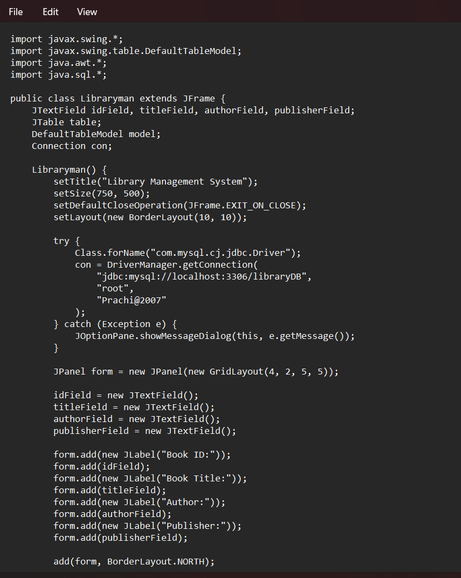 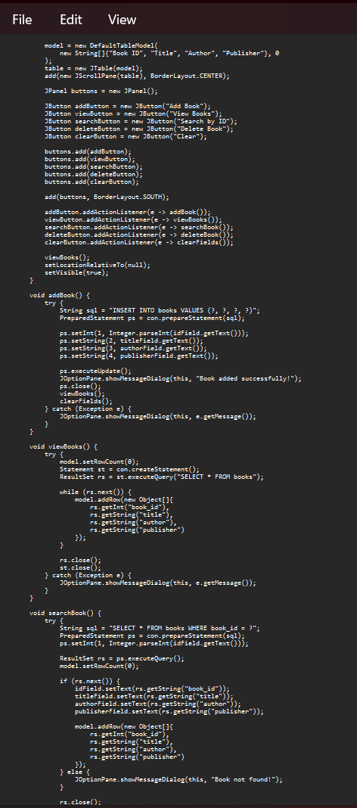 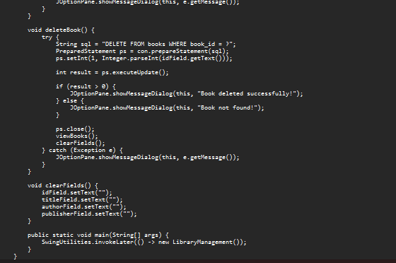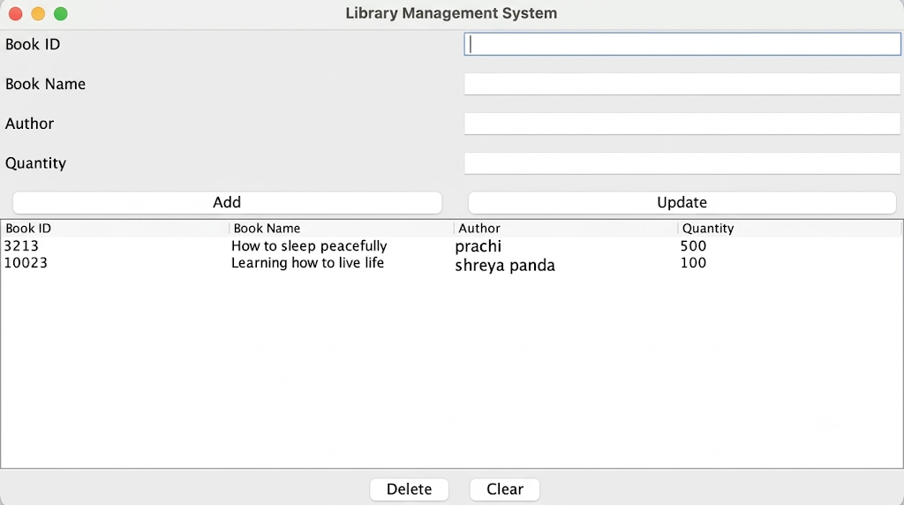

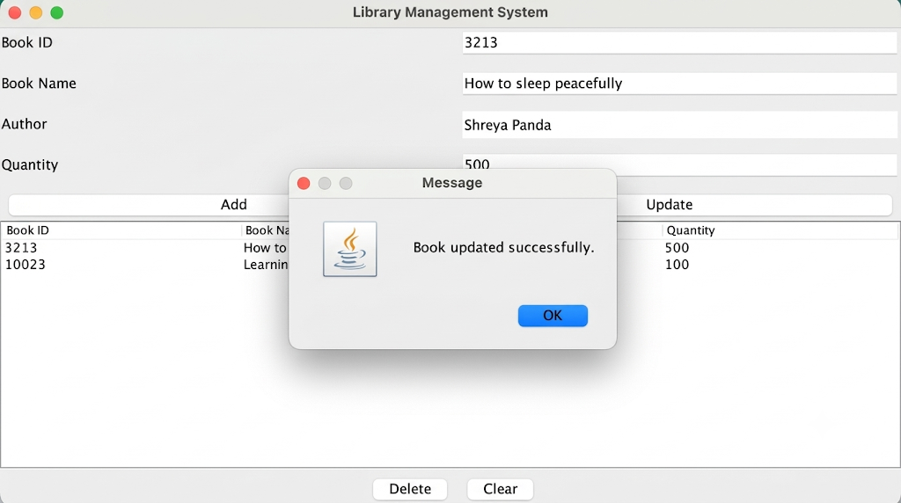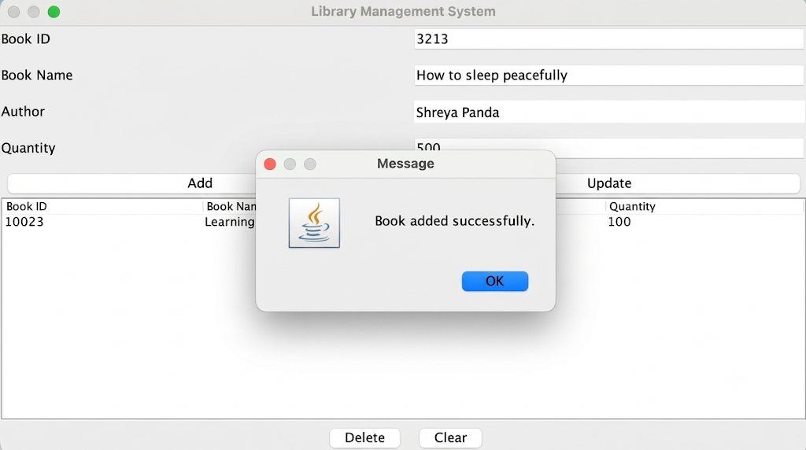

2. Create a Book Issue Tracking System GUI application using Java Swing connected to a database. The system should store book ID, student name, issue date, and return date, and allow record management.

